**INSTRUCTIONS FOR USING THE KEPLER/TESS FITS v2.2 FILE VStar PLUG IN**

With the availability of the TESS light-curves, this plugin now handles Kepler, K2 and TESS light-curve files. In addition, there is now a [unified MAST portal](https://mast.stsci.edu/portal/Mashup/Clients/Mast/Portal.html) that allows you to download Kepler, K2 and TESS light-curves along with many other data products from these and other missions. The portal is well documented. Therefore, this document simply provides a quick start in the form of three examples.

**Kepler Exoplanet Example**

On the MAST portal, enter the target name and search radius. The default radius is 0.2 degrees, so you usually want something smaller. Try using a radius of 5 arcsec for the exoplanet Kepler-12 – “kepler-12 r=5s”. 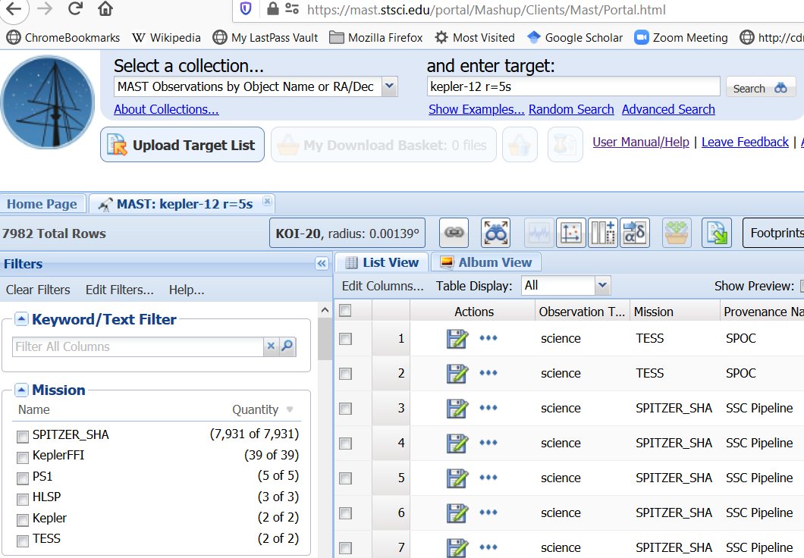There is a very long list of results. We are looking for light-curve results from Kepler. Select the Kepler Mission and you should now see two light-curve results. Download the first of these two by clicking the top diskette icon.

Inside the downloaded ZIP file is a dictory tree with PDF files and a TAR file at the lowest level. The PDF files contain reports on the observations. The TAR file contains the light-curves. Extract the files with “tar”. This command is available on Linux, MacOS and current versions of Windows. For the latter, use the command line Windows program and issue the command

>tar xf kplr011804465_lc_Q111111110111011101.tar

You will now find a set of FITS files with the light-curves for various dates in the folder 011804465.

*Note. Kepler and TESS FITS files contain photometric data in two versions. The first is “Simple Aperture Photometry” (SAP) data, the second one is “Pre-search Data Conditioning Simple Aperture Photometry” (PDCSAP). PDCSAP data are commonly better because it is supposed that systematic artifacts are removed from them. Sometimes, however, PDCSAP data are “overcorrected” and looks worse than “raw” PDC data. The plugin version 2.2 has the capability to select PDCSAP (corrected) or PDC (raw) versions while loading data.*

Now comes the easy part. Select New Star From Kepler/TESS FITS v2.2 from the file drop down list.

Then select one of the extracted FITS files. You will see a data selection dialog:

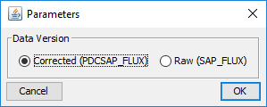

Let’s select corrected data and press OK. VStar will show you the light curve:

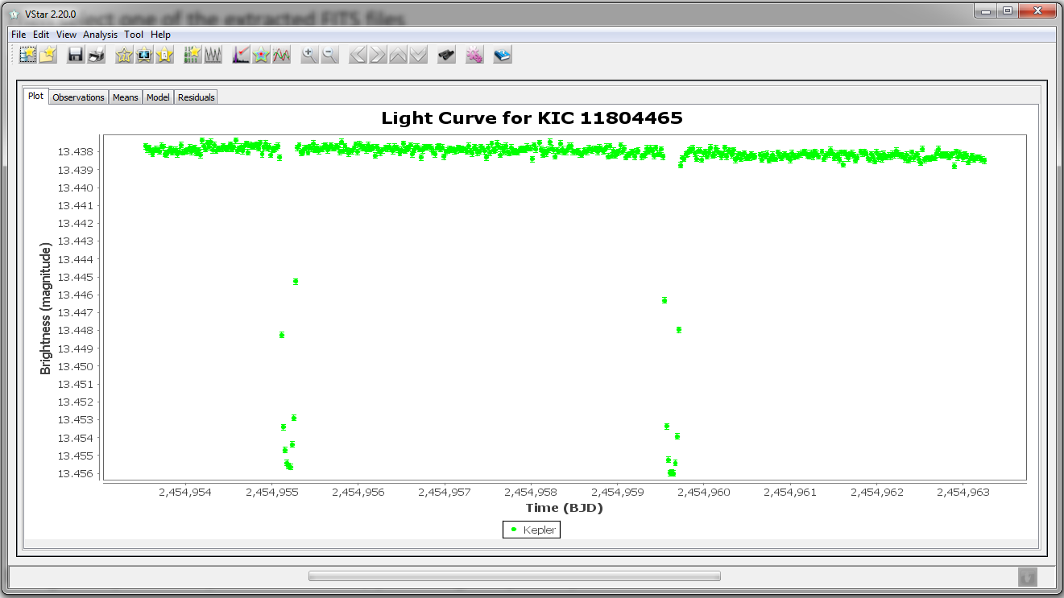

Using the epoch and period from VSX, you can get a phase plot:

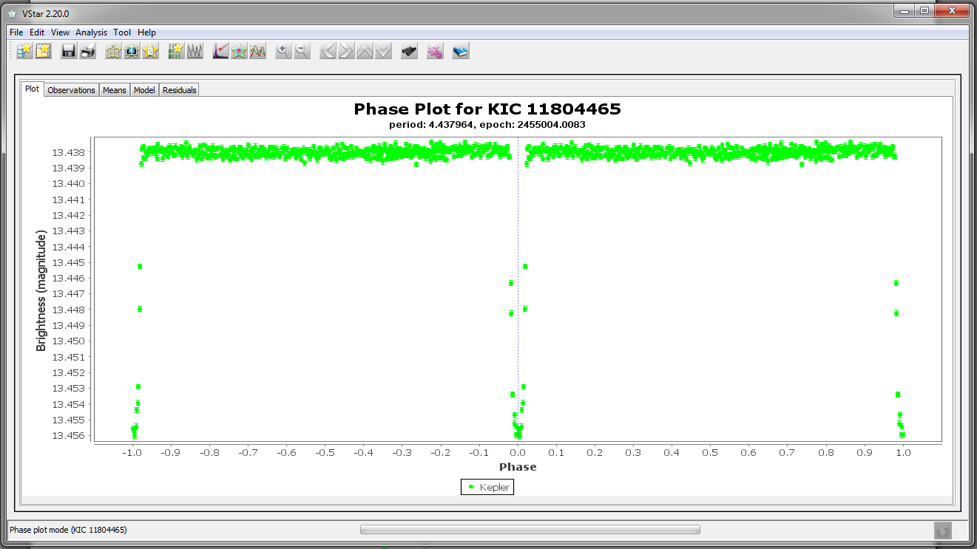

If you want to add Kepler Data files together you can use the “Add to Current” check box at the top right of the open file dialog.

Kepler data is NOT restricted to Kepler exoplanet objects of interest. You can find data on essentially any star in the field, certainly any star that was in the Kepler input file. Also, ASAS imaged most of the field for about 6 months in 1999 in preparation for the Kepler mission. You can cross index ASAS and Kepler IDs for objects in the field.   
  
**TESS T Antliae (T Ant) Cepheid Example**

Now we want to see what TESS observed for the classical Cepheid T Ant. When using TESS, you must be aware that this is an all-sky survey mission with a large angle of the sky contained in each camera pixel – 21 arcsec. An aperture just 3 pixels wide contains a full arcmin. To determine if we are likely to get a measure of T Ant by itself, search VSX for all variables within 1 arcmin of the coordinates for T Ant – “09 33 50.86 -36 36 56.8”. We find there are no others.

On the MAST portal, enter target “T Ant r=5s”. Select the TESS mission to narrow the result set and you should see three light-curve results. Click on the light-curve icon for first of these. You are told there is no timeseries data, so we cannot use this one. Download the second one and, as before, extract the ZIP. This time, there is no TAR – the light-curve FITS is at the lowest level. It is the file ending in “s_lc.fits”

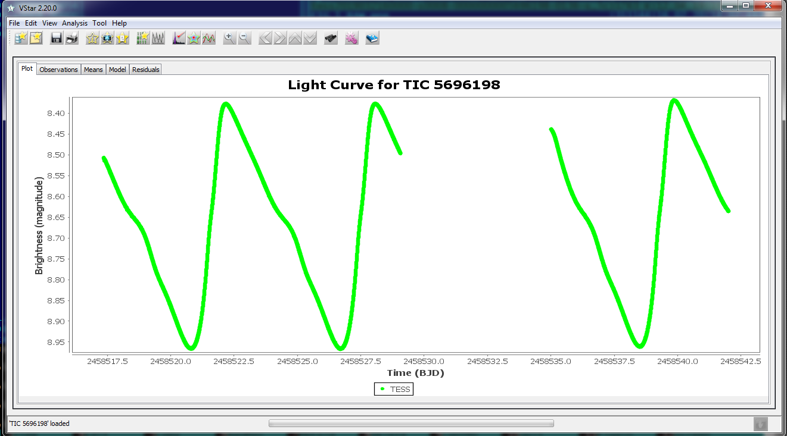

The brightness in magnitudes is calculated from the flux contained in the FITS file. Zero point is adjusted so that the median magnitude for the light curve is set to a magnitude value, extracted from FITS header. For Kepler data, it is a value specified by the “KEPMAG” keyword in the header, for TESS it is a value of “TESSMAG” keyword.

**K2 Eclipsing Binary Example ASAS J035812+1629.7**

Looking at VSX for the Algol type EB, ASAS J035812+1629.7 we see two other names that start with “EPIC”. These indicate K2 observations. If we try the MAST portal for ASAS J035812+1629.7, we are told it cannot resolve that name. We can use coordinates or one of the VSX other names – EPIC, HD, etc. Use “HD 285322,r=10s”. Limit the result set by picking the K2 mission.

Download the one with Provenance Name (source) K2. Unzip the file and at the lowest folder is the light-curve file - ktwo210568214-c04_llc.fits. Opening it and doing a phase plot yields this

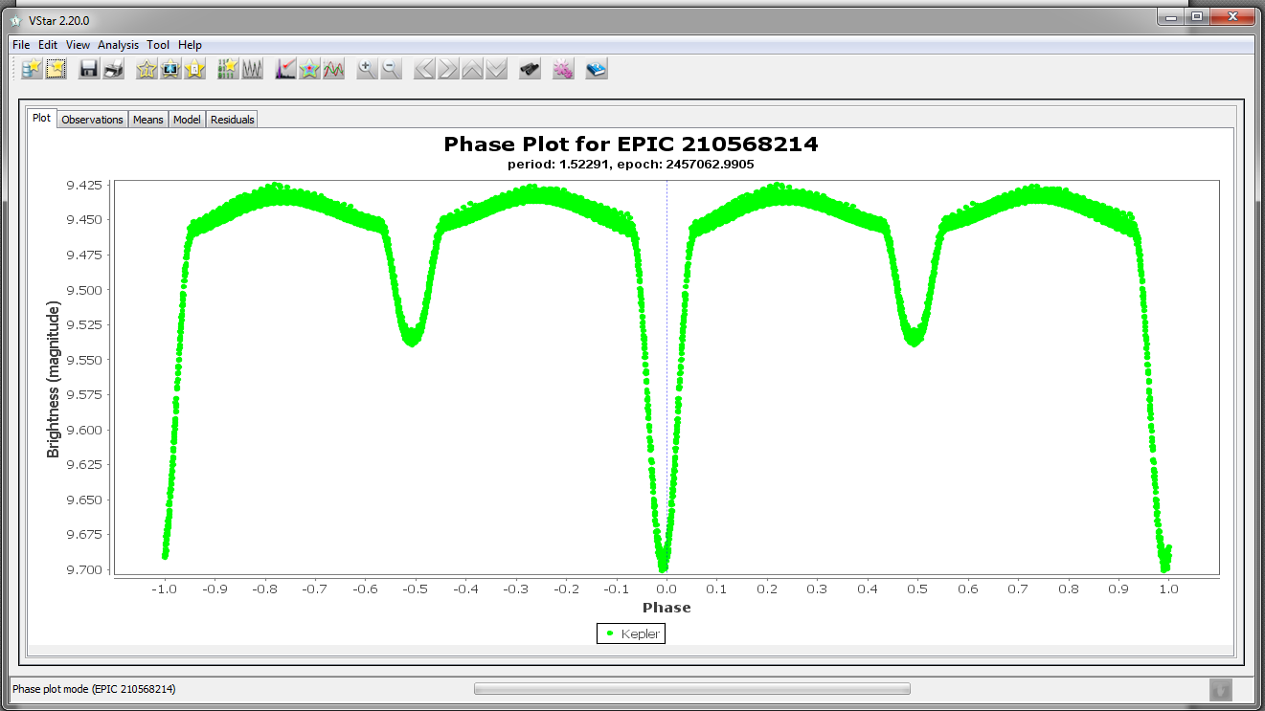

Brad Walter, WBY

Cliff Kotnik, KCLA

Maksym Pyatnytskyy, PMAK

Rev H  
2020-02-27

**Revision History**

|  |  |  |
| --- | --- | --- |
| **Rev** | **Date** | **Description** |
| A | 6/7/2014 | Initial Release |
| B | 6/8/2014 | Added item 10 |
| C | 6/9/2014 | Added Footnote 1, changed text in item 10 describing locations of the “Search” buttons and added revision history |
| D | 6/9/2014 | Correct item 10 |
| E | 6/10/2014 | Correct item 7 & add page numbers |
| F | 11/7/2018 | Alter intro to add instruction for either Kepler or K2 (C. Kotnik) |
| G | 1/8/2020 | TESS and MAST portal rewrite. (C. Kotnik) |
| H | 2/27/2020 | Plugin v2.2: 1) PDCSAP/PDC selection dialog; 2) Magnitude adjustment to TESSMAG/KEPMAG FITS Header value, figures updated. (M. Pyatnytskyy) |